CanberraUAV
Deliverable 3
Autonomous Flight Record

www.canberraUAV.org.au
04/08/2014

Table of Contents
1 Table of Contents 1
2 Flight Logs 2
2.1 Flight Log Book 2
2.2 GPS Telemetry 3
2.3 Video 3
2.4 Static Images 3
3 RF Transmitters 7
3.1 2.4 GHz RC Link 7
3.2 900 MHz Telemetry Link 7
3.3 433 MHz Telemetry Link 7
3.4 5.8 GHz Image and Telemetry Link 7
3.5 Voice Communications 8
4 Aircraft Specifications and Performance 9

Flight Logs

Flight Log Book
The following is an extract from our flight log book.
Date | Aircraft | Start  Time | AUTO  time | Flight Comments | DroneShare link
30/04/14 | Bushmaster | 10:09 | 0:04:57 | D2 video capture. First flight with enlarged tail – handled very well. | www.droneshare.com/mission/11495
11/05/14 | Bushmaster | 9:52 | 0:03:39 | Tuned the airspeed sensor and tested ground handling. | www.droneshare.com/mission/11488
18/05/14 | Bushmaster | 10:25 | 0:27:32 | Tested new (bigger) fuel tanks. | www.droneshare.com/mission/11503
18/05/14 | Bushmaster | 11:35 | 1:00:41 | First long-endurance flight. All went well. | www.droneshare.com/mission/11502
25/05/14 | Bushmaster | 10:47 | 0:01:51 | Second endurance flight. Aborted due to crash | www.droneshare.com/mission/11510
05/07/14 | Bushmaster | 10:18 | 0:11:02 | First AUTO flight of repaired airframe. | www.droneshare.com/mission/11509
06/07/14 | Bushmaster | 8:35 | 0:17:21 | Flight test before endurance flights | www.droneshare.com/mission/11508
06/07/14 | Bushmaster | 9:31 | 1:00:57 | First endurance flight | www.droneshare.com/mission/11512
06/07/14 | Bushmaster | 11:25 | 1:00:15 | Second endurance flight | www.droneshare.com/mission/11511
13/07/14 | Bushmaster | 9:38 | 1:00:37 | Endurance flight with camera and image processing on-board | www.droneshare.com/mission/11516
20/07/14 | Bushmaster | 14:04 | 0:06:32 | Flight with remote ground station > 5km away. | www.droneshare.com/mission/11518
20/07/14 | Bushmaster | 11:14 | 0:48:22 | Endurance flight with camera and image processing on-board | www.droneshare.com/mission/11515
02/08/14 | Bushmaster | 10:16 | 1:00:09 | Endurance flight with camera and image processing on-board | www.droneshare.com/mission/12016
02/08/14 | Bushmaster | 13:10 | 0:14:47 | Bottle drop test | www.droneshare.com/mission/12015
03/08/14 | Bushmaster | 10:59 | 0:11:07 | Bottle drop and ground station test | www.droneshare.com/mission/12107
03/08/14 | Bushmaster | 12:22 | 0:06:02 | Bottle drop and ground station test | www.droneshare.com/mission/12106
03/08/14 | Bushmaster | 13:12 | 0:07:03 | Bottle drop and ground station test | www.droneshare.com/mission/12108
 | Total |  | 7:42:54

Our full flight logs are available at www.droneshare.com/vehicle/1085 and http://uav.tridgell.net/Bushmaster/OBC-2014-auto/. They contain the full GPS tracks (in kml and gpx format) and flight telemetry (in tlog format).

GPS Telemetry
A KML log from a flight on the 20th June 2014 is shown below:
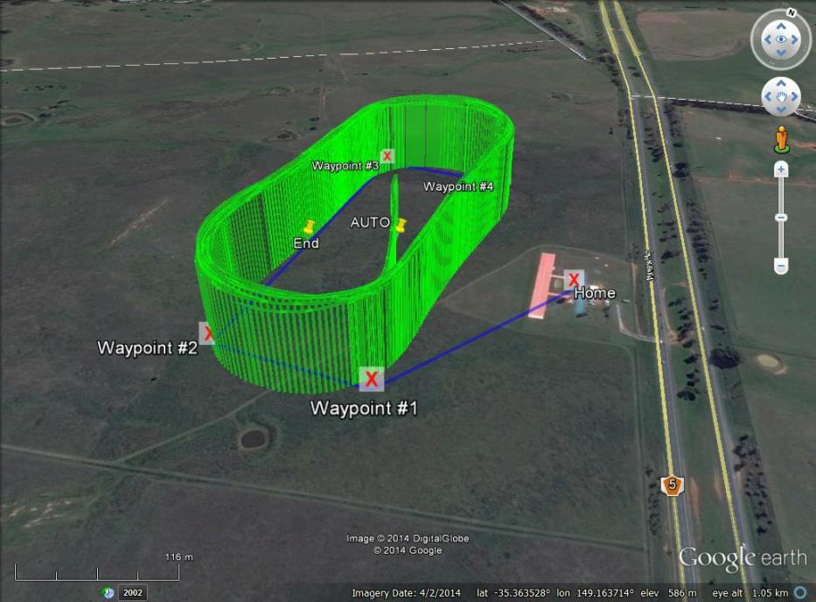
The full file is available from https://api.droneshare.com/api/v1/mission/11515/messages.kmz.

Video
A video showing the aircraft during autonomous flight and the operational ground station is available at http://youtu.be/fzzPpzbPJj0.

Static Images
The following are a set of static images showing the ground station, aircraft and team members during flight operations from a number of flights over the last 3 months.
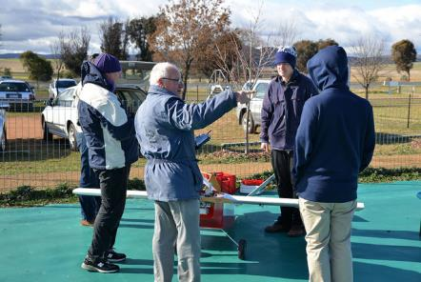 | Pre-flight team briefing
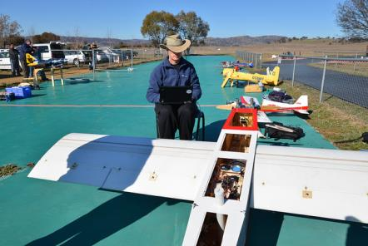 | Pre-flight checks
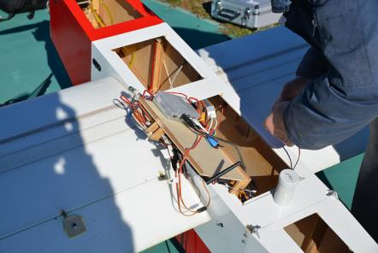 | Pre-flight checks
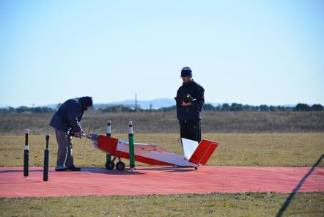 | Engine start
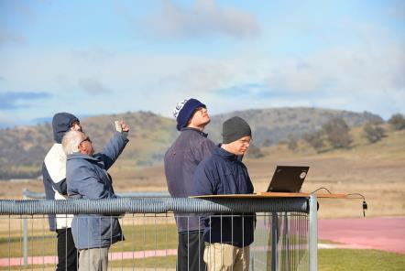 | Monitoring the UAV during flight
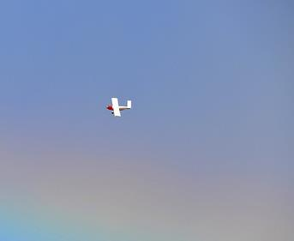 | Flying the search pattern
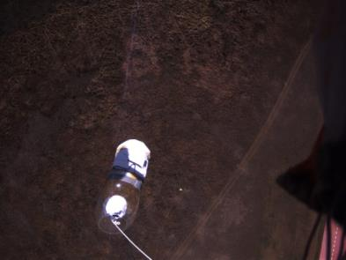 | Dropping a bottle to Joe
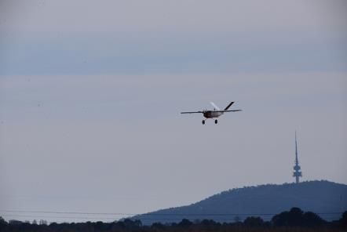 | Approach to landing
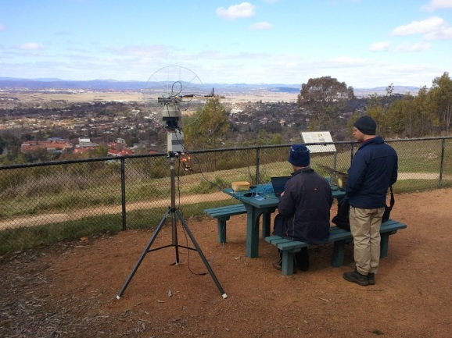 | Ground station test
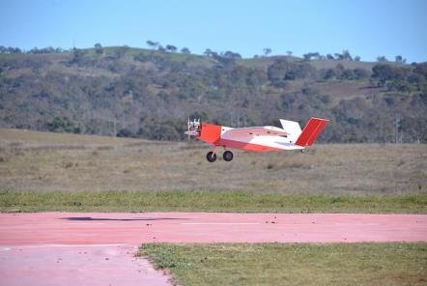 | Landing
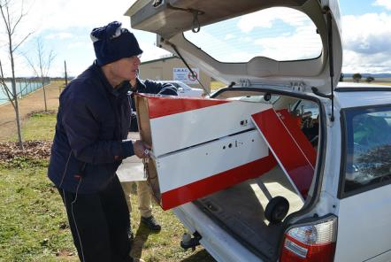 | Packing the UAV away after test flights

RF Transmitters

2.4 GHz RC Link
This link is used for manual RC control of the UAV’s throttle and flight control surfaces.
Specification | Value
Model | FrSky Taranis 2.4 GHz (using a FrSky X9D transmitter module)
Transmission Frequency | 2400 – 2483.5 MHz
Transmitter Power | 60 mW (17 dBm)
Transmitter antenna gain | < 5 dBi
Calculated EIRP | < 23 dBm
Covering licence | Radiocommunications (Low Interference Potential Devices) Class Licence 2000. Part 45A, 53, 54

900 MHz Telemetry Link
This is a low bandwidth link for transmitting telemetry from the UAV to Ground Station. Commands can be sent from the Ground Station to UAV when necessary. They have been calibrated and tested for LIPD-2000 (Part 52) compliance by RFDesigns RF lab in Brisbane.
Specification | Value
Model | RFD900 Telemetry Radio
Transmission Frequency | 915 – 928 MHz, 20 Channel Hopping
Transmitter Power | 27 dBm (UAV) 24 dBm (Ground)
Transmitter antenna gain | 3 dBi (UAV) 6 dBi (Ground)
Calculated EIRP | 30 dBm (UAV) 30 dBm (Ground)
Covering licence | Radiocommunications (Low Interference Potential Devices) Class Licence 2000. Part 52

433 MHz Telemetry Link
This is a low bandwidth link for transmitting telemetry to the Tracking Antenna from the Ground Station. This is in order to provide the position of the UAV so the Antenna knows which direction to point.
Specification | Value
Model | 3D Robotics 433MHz Radio
Transmission Frequency | 433.05 – 434 MHz, channel hopping
Transmitter Power | 10 dBm (Antenna) 10 dBm (Ground)
Transmitter antenna gain | 2 dBi (Antenna) 2 dBi (Ground)
Calculated EIRP | 12 dBm (Antenna) 12 dBm (Ground)
Covering licence | Radiocommunications (Low Interference Potential Devices) Class Licence 2000. Part 17

5.8 GHz Image and Telemetry Link
This is a high bandwidth link for transmitting images from the UAV’s on-board cameras to the Ground Station. As a backup, the telemetry and command datastream also uses this link.
Specification | Value
Model | Ubiquiti Rocket
Transmission Frequency | 5795 MHz
Transmitter Power | 26 dBm (UAV) 8 dBm (Ground)
Transmitter antenna gain | 10 dBi (UAV) 28 dBi (Ground)
Calculated EIRP | 36 dBm (UAV) 36 dBm (Ground)
Covering licence | Radiocommunications (Low Interference Potential Devices) Class Licence 2000. Part 45B, 55  “C-tick” No. N14691

Voice Communications
This is a voice radio link using CB radios. It will be used to facilitate communications between the pilot and ground station during setup, takeoff, landing and pack-up.
Specification | Value
Model | Uniden UH015SX and Uniden UH078SX handheld CB
Transmission Frequency | 476.425 -477.400 MHz
Transmitter Power | 6.9 dBm
Transmitter antenna gain | 3 dBi
Calculated EIRP | 9.9 dBm
Covering licence | Radiocommunications (Citizen Band Radio Stations) Class Licence 2002. “C-tick” No. N32Z068

Aircraft Specifications and Performance
The Aircraft platform used by Canberra UAV is a custom built aircraft called the “Bushmaster”. It has the following specifications:
Specification | Value
Maximum Airspeed | 64 kts (115 Km/h)
Cruise Airspeed | 56 kts (100 Km/h)
Endurance at maximum airspeed | Estimated 60 minutes
Endurance at cruise airspeed | 90 minutes
Maximum take off weight | 20 Kg
Competition take off weight | 15 Kg
Wingspan | 2.6 m
Airframe length | 2 m
Identifying marks | White with red trim
Aircraft planform and configuration | High wing V-tail tractor aircraft

